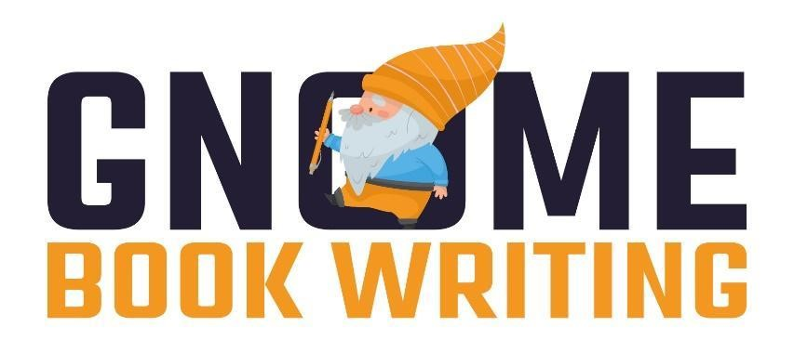

**Marketing**

**Service Agreement**

This agreement is made as of February 15th, 2024, by and between Gnome Book Writing (“Service Provider”) and Justin D. Hoke (“Client”).

In consideration of the mutual covenants made herein, the parties agree as follows:

# PARTIES

The Service Provider is in the business of providing services related to, but not limited to, ghostwriting, book editing, book publishing, book marketing and distribution. The Service Provider also designs and develops websites and mobile applications, provides digital marketing services, online reputation management, Wikipedia writing and publishing, and general content writing services. The Client wants to employ the services of the Service Provider.

# SERVICES TO BE PROVIDED

The Service Provider agrees to complete and deliver the following set of services purchased by the client:

**Social Media Marketing: $2500**

• Researched Target Audience

• Facebook Paid Advertising

• Instagram Paid Advertising

• Twitter Engagement

• LinkedIn Engagements

• 3 posts a week for 3 months

• Exclusive campaigns

• Social Media Boosting and Promotion

• Creative Social Media Content

• Promotion and Hype Building

• Audience Engagement

• Progress Tracking and Reporting

• Ongoing Support

• Backlinking

• Paid Advertisement

• Optimization

• Influencer Marketing

# REPRESENTATIONS AND WARRANTIES OF SERVICE PROVIDER

The Service Provider represents and warrants that all services rendered under this Agreement will be original works of authorship of Service Provider and will not infringe upon or violate any third party's intellectual property right.

# COMPENSATION

The Client shall pay the Service Provider the requested amount of **$2500** in totalfor the services listed in **Section 2: Services to be provided**. Out of which **$1000** shall be paid upfront and the remaining will be due at a later date. Service Provider agrees to invoice the Client for the services rendered under this Agreement. Any other services purchased by the Client from the Service Provider will be invoiced separately and will have no relation to this agreement.If the Client is dissatisfied with the services provided, they are entitled to request a full refund at any time, and the refund will be processed within 24-48 hours.

# CONTRACT PERIOD

This Agreement will begin on the date set forth below and shall continue for this project's duration unless terminated earlier by either party as provided herein. If either party violates a term of this Agreement, then the other party may terminate this Agreement, effective immediately upon delivery of the written notice of termination to the party in violation.

# INDEPENDENT CONTRACTOR

The parties expressly understand and agree that Service Provider is providing services to the Client under this Agreement as an independent contractor. As such, Service Provider will not be an employee of Client and shall not be entitled to any employee benefits Client provides or may provide to its employees, including but not limited to health insurance, life insurance, sick leave, retirement plans, and/or paid time off such as vacation and holiday pay.

# ASSIGNMENT AND OWNERSHIP OF INTELLECTUAL PROPERTY

Service Provider expressly acknowledges that the parties have agreed that all copyrightable aspects of completed projects under this Agreement are to be considered “works made for hire” within the meaning of the Copyright Act of 1976, as amended (the “Act”), of which the Client is to be the “author” within the meaning of the Act. All such copyrightable works, as well as all copies of such works in whatever medium fixed or embodied, shall be owned exclusively by Client on their creation, and Service Provider hereby expressly disclaims any interest in any of them.

# CONFIDENTIALITY

For the purposes of enabling the Service Provider to provide the professional services to the Client, the Client agrees to provide the Service Provider with written and oral information

(“Confidential Information”) concerning the project which the Service Provider is to complete (“Project”) subject to the terms of this Agreement.

Service Provider agrees not to disclose any Confidential Information or trade secrets of Client to others. Client considers all information Service Provider has or will receive regarding Client, its business, or its clients to be strictly confidential. Client acknowledges he or she is executing a non-disclosure agreement along with this Agreement; said non-disclosure agreement is incorporated herein by reference.

The Confidential Information shall be kept in strict confidence by the Service Provider and shall not be used, without the Client’s prior written consent, for any purpose other than in connection with the completion of the Project. The Confidential Information shall not be disclosed to any persons other than those Representatives (as defined below) who have a need to know. “Representatives” shall mean the affiliates, directors, officers, employees, professional advisers, and agents of the Service Provider. The Service Provider shall inform its Representatives of the confidential nature of the Confidential Information and shall direct its Representatives to hold the Confidential Information in strict confidence.

The restrictions in the paragraph above shall not apply to any information which: (a) is or becomes generally available to the public through no violation of this Agreement; (b) was available to the Service Provider on a non-confidential basis prior to its disclosure to the Service Provider by the Client; (c) becomes available to the Service Provider on a nonconfidential basis from a source other than the Client provided that such source is not bound by an Agreement with the Client; or (d) is required to be disclosed to any court, regulatory authority, other governmental authority or pursuant to any requirement of law.

At the request of the Client, the Service Provider shall return all Confidential Information received from the Client and shall not retain any copies of, or other reproductions or extracts of, the Confidential Information, except as it may retain in accordance with prudent business practices (any retained material shall remain subject to the provisions of this Agreement without any time limit).

# SEVERABILITY

If any provision of this Agreement is held to be invalid or unenforceable, such provision shall be deemed to be separable and divisible from the remaining provisions, which shall continue to be valid and enforceable as though the invalid and unenforceable provisions had not been included therein; such separation and divisibility may be done on a word-by-word basis within the paragraphs of this Agreement in order to sustain the intent of the Agreement.

**10. ENTIRE AGREEMENT.**

This Agreement, along with the non-disclosure agreement referenced in Section 8, above, and incorporated herein by reference, constitutes the entire agreement between the parties with regard to the matters set forth herein and supersedes all prior agreements, proposals, and representations, whether oral or written, express or implied, with regard thereto, and shall not be modified unless in writing signed by both parties.

|  |  |
| --- | --- |
| **SERVICE PROVIDER**  Gnome Book Writing      **Sign: _Jason Hawks______________**  **Name: Jason Hawks**  **Designation: Manager Compliance**  **Date:** 02/15/2024  **Phone:** +1-218-300-9881 Ext. 107  **Email:** info@gnomebookwriting.com | **CLIENT**  Justin D. Hoke      **Sign: __________________________**  **Name: Justin D. Hoke**  **Organization:**  **Date:** 02/15/2024  **Phone: 503-853-4621**  **Email:** Justinhokekw@gmail.com |